**CREATE AN ACCOUNT IN FACEBOOK:**

It is possible to link your Facebook and Google accounts with your Sogolytics account. This enables you to log in to your Sogolytics account using the linked Google and/or Facebook accounts.

To link your accounts, follow these steps:

1. Click on your account initials in the top right corner, then choose Account Settings from the dropdown menu.
2. Click Linked Account in the menu on the left.
3. Click on ‘Link Your Facebook Account’ and/or ‘Link Your Google Account’.

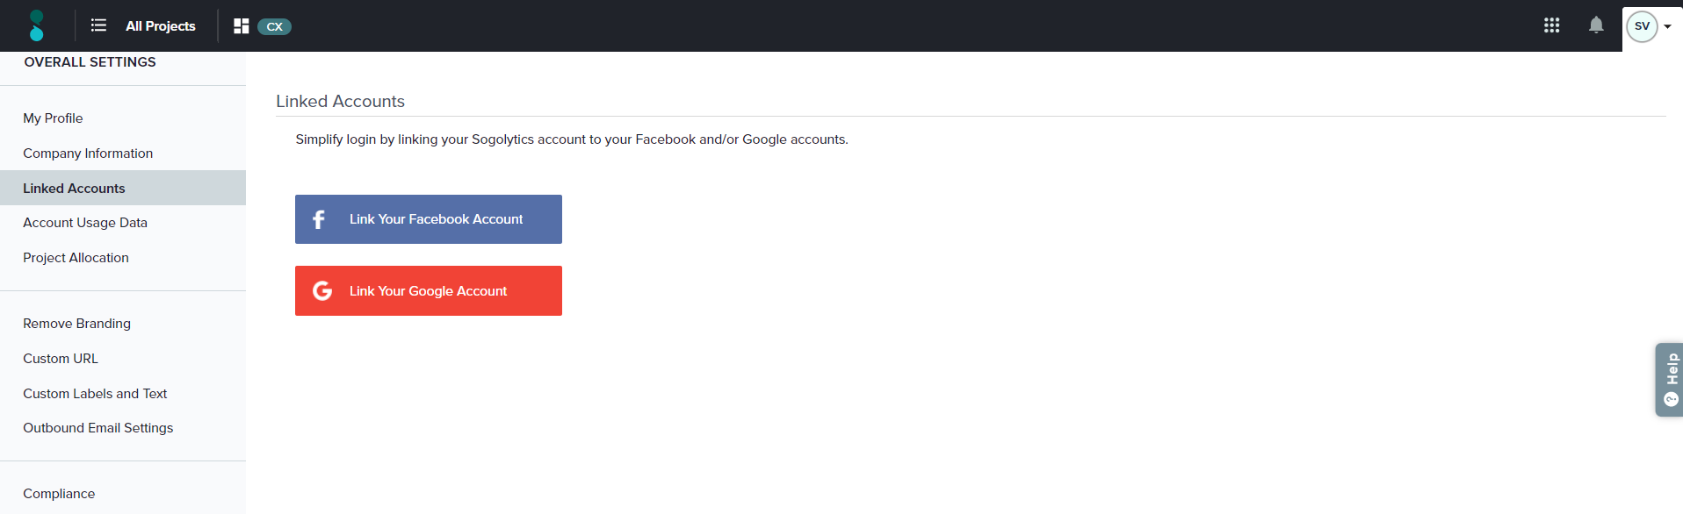

1. Enter the requested login details.

If you wish to dissociate the linked accounts at any time, just follow these steps:

1. Click on your account initials in the top right corner, then choose Account Settings from the dropdown menu.
2. Click Linked Account in the menu on the left.
3. Click ‘Disconnect and link a different account’ next to the relevant account.